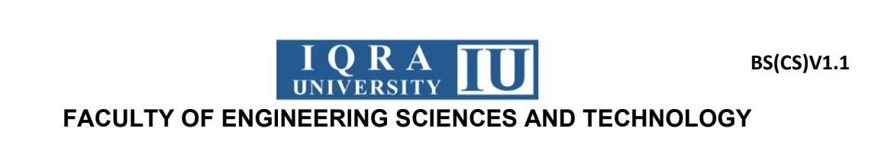

Mapped CLO | SDG | Complex Problem Solving Mapped
CLO3 | 4 | WP1 (Range of conflicting requirements required)
CLO3 | 4 | WP2 (Depth of analysis required)
CLO3 | 4 | WP3 (Depth of knowledge required)
Announced Date: 1st/may/2026
Due Date: 2nd/june/2026
Total Marks: 08

Title: Implement a Syntax Analyzer for SimpleLang with Function prototype and calling Support
Problem Statement:
The objective of this assignment is to design and implement a syntax analyzer (parser) for a simplified instructional programming language called SimpleLang. The parser must verify whether the input source code conforms to formally defined grammar rules of the language.The syntax analyzer should process tokenized input and validate syntactic correctness using a structured parsing technique such as Recursive Descent Parsing or LL(1) Parsing. Additionally, the parser must support function declarations, function calls, and parameter handling, along with previously defined constructs such as declarations, assignments, expressions, and control structures.The parser must also detect syntax errors and generate informative error messages including line numbers and error descriptions.

Constraints and Assumptions

Grammar Specifications
SimpleLang supports the following constructs:

1. Variable Declarations
int hirafarman;
bool flag;
string name;

2. Assignment Statements
x = hira_10;
flag = true;

3. Expressions
x + 1
(flag && true)
far * man + 5

4. Conditional Statements
if (age > 80) {
age = age - 1;
}

5. Loop Structures
for (int i = 0; i < 10; i = i + 1) {
x = x + i;
}
while (x < 10) {
x = x + 1;
}

6. Function Declarations
int farman_add(int a, int b) {
return a + b;
}
void displayfarmanfunc() {
x = 10;
}

7. Function Calls
x = farman_add(5, 3);
displayfarmanfunc();

Lexical Token Assumptions
The parser assumes tokens are categorized as:
Keywords
int, bool, string, void, if, for, while, return
Operators(arithmetic, relational , logical)
+, -, *, /, =, <, >, &&, ||
Symbols/ bracket/ parentheses (assume as discussed in class)
; { } ( ) ,
Identifiers(ID)
Variable names beginning with alphabetic characters followed by alphanumeric characters.

Syntax Rules Specification (EBNF Structure)
Your grammar must define:
- Variable declarations
- Assignment statements
- Expressions
- Conditional statements
- Loop statements
- Function declarations
- Function calls
- Return statements
- Program entry structure
Example structure:
Program → DeclarationList StatementList FunctionList
Function → Type Identifier ( ParameterList ) Block
FunctionCall → Identifier ( ArgumentList )
ReturnStmt → return Expression ;

Expected Outcomes

1. Parser Implementation
The parser should:
- Process token sequences generated from SimpleLang programs
- Validate syntax using Recursive Descent or LL(1)
- Support functions, loops, declarations, and expressions
- Detect invalid grammar structures

2. Error Handling
The parser must:
- Detect missing symbols such as semicolons or braces
- Identify incorrect declarations
- Detect invalid function definitions
- Report syntax violations with line numbers
Example:
Syntax Error at line 6: Missing closing brace

3. Testing Requirements
Five structured test programs must be included:
- One valid program using all constructs including functions
- One program with syntax error in variable declaration
- One program missing a closing brace
- One program with invalid assignment expression
- One program with incorrect function declaration

Deliverables and Marking Scheme

Component | Description | Marks
Correctness | Accurate syntax validation of SimpleLang programs through proper parser implementation and correct recognition of valid grammatical structures | 4
Design & Organization | Clear structuring of parser modules along with well-defined grammar rules and logical organization of syntax analysis workflow | 2
Error Reporting | Generation of precise and meaningful syntax error messages including line-number level diagnostics | 1
Manual Grammar Writing | Formal specification of SimpleLang grammar using BNF/EBNF notation covering declarations, expressions, control structures, and function definitions | 2

Complex Problem Solving Mapping

WP | Attribute | Description | Compiler Construction CCP Mapping
WP1 | Range of Conflicting Requirements | Integration of declarations, expressions, control structures, and function handling within a unified parser | Demonstrates ability to manage multiple interacting compiler components simultaneously
WP2 | Depth of Analysis | Development of grammar rules using EBNF and structured parsing algorithms | Reflects analytical understanding of syntax-directed parsing techniques
WP3 | Depth of Knowledge | Validation using structured test programs including function-level syntax verification | Demonstrates applied knowledge of compiler design and syntax validation mechanisms

